Transformation Conditions

Definition
# Source: AI Source: Provided by: [Data Path: Persons Table -> ID Column: 1, Name_En Column: Motasem Essam] -> From: [ChatGPT] on [7/25/2026]
Transformation Conditions are geometric conditions that specify that a geometric object, point, line, segment, angle, or figure must be related to another object through a particular geometric transformation.
A transformation condition may require a figure to be:
- translated,
- reflected,
- rotated,
- enlarged or reduced,
- mapped by a composition of transformations,
- congruent or similar to another figure,
- or positioned according to a specified transformation rule.
In general, if $T$is a transformation, a transformation condition can be written as:
$$\boxed{T\left(F\right)=F^{'}}$$
where:
- $F$= original figure,
- $T$= transformation,
- $F^{'}$= transformed figure.
For a symmetry condition, the special case is:
$$\boxed{T\left(F\right)=F}$$
meaning the transformation maps the figure onto itself.
Simple Definition
A Transformation Condition is a geometric requirement stating that one object or figure must be the image of another under a specified transformation.

Classification of Transformation Conditions
# Source: AI Source: Provided by: [Data Path: Persons Table -> ID Column: 1, Name_En Column: Motasem Essam] -> From: [ChatGPT] on [7/25/2026]
A practical classification is:
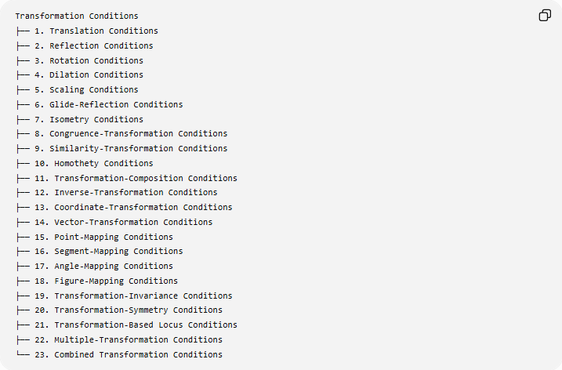
Transformation Conditions
├── 1. Translation Conditions
├── 2. Reflection Conditions
├── 3. Rotation Conditions
├── 4. Dilation Conditions
├── 5. Scaling Conditions
├── 6. Glide-Reflection Conditions
├── 7. Isometry Conditions
├── 8. Congruence-Transformation Conditions
├── 9. Similarity-Transformation Conditions
├── 10. Homothety Conditions
├── 11. Transformation-Composition Conditions
├── 12. Inverse-Transformation Conditions
├── 13. Coordinate-Transformation Conditions
├── 14. Vector-Transformation Conditions
├── 15. Point-Mapping Conditions
├── 16. Segment-Mapping Conditions
├── 17. Angle-Mapping Conditions
├── 18. Figure-Mapping Conditions
├── 19. Transformation-Invariance Conditions
├── 20. Transformation-Symmetry Conditions
├── 21. Transformation-Based Locus Conditions
├── 22. Multiple-Transformation Conditions
└── 23. Combined Transformation Conditions

1. Translation Conditions
# Source: AI Source: Provided by: [Data Path: Persons Table -> ID Column: 1, Name_En Column: Motasem Essam] -> From: [ChatGPT] on [7/25/2026]
Definition
A Translation Condition requires an object to be moved by a specified displacement vector without changing its size, shape, or orientation.
If $T_{\vec{v}}$is a translation:
$$\boxed{T_{\vec{v}}\left(P\right)=P^{'}}$$
with:
$$\vec{PP^{'}}=\vec{v}$$
Coordinate Form
For translation by $\left(a , b\right)$:
$$\boxed{\left(x , y\right)→\left(x , +ay+b\right)}$$
Example
Translate:
$$A\left(1 , 2\right)$$
by:
$$\vec{v}=\left(3 , -1\right)$$
Then:
$$A^{'}\left(1 , +32-1\right) \\ \boxed{A^{'}\left(4 , 1\right)}$$
A translation preserves:
- lengths,
- angles,
- parallelism,
- orientation,
- area.

2. Reflection Conditions
# Source: AI Source: Provided by: [Data Path: Persons Table -> ID Column: 1, Name_En Column: Motasem Essam] -> From: [ChatGPT] on [7/25/2026]
Definition
A Reflection Condition requires an object to be the mirror image of another object across a specified line, plane, or other reflection set.
For reflection across line $l$:
$$\boxed{R_{l}\left(F\right)=F^{'}}$$
For a point $P$and its reflection $P^{'}$:
$$PP^{'}⊥l$$
and:
$$d\left(P , l\right)=d\left(P^{'} , l\right)$$
Example
Reflect:
$$P\left(2 , 3\right)$$
across the $x$-axis.
The transformation is:
$$\boxed{\left(x , y\right)→\left(x , -y\right)}$$
Therefore:
$$\boxed{P^{'}\left(2 , -3\right)}$$
Reflection preserves lengths and angles but reverses orientation.

3. Rotation Conditions
# Source: AI Source: Provided by: [Data Path: Persons Table -> ID Column: 1, Name_En Column: Motasem Essam] -> From: [ChatGPT] on [7/25/2026]
Definition
A Rotation Condition requires an object to be mapped to another object by rotating it through a specified angle around a fixed center.
$$\boxed{R_{O,θ}\left(F\right)=F^{'}}$$
where:
- $O$= center of rotation,
- $θ$= angle of rotation.
For every point:
$$OP=OP^{'}$$
and:
$$∠POP^{'}=θ$$
Example
Rotate:
$$P\left(2 , 1\right)$$
${90}^{∘}$counterclockwise about the origin.
The transformation is:
$$\boxed{\left(x , y\right)→\left(- , yx\right)}$$
Therefore:
$$\boxed{P^{'}\left(- , 12\right)}$$

4. Dilation Conditions
# Source: AI Source: Provided by: [Data Path: Persons Table -> ID Column: 1, Name_En Column: Motasem Essam] -> From: [ChatGPT] on [7/25/2026]
Definition
A Dilation Condition requires a figure to be enlarged or reduced relative to a fixed center by a specified scale factor.
$$\boxed{D_{O,k}\left(F\right)=F^{'}}$$
where:
- $O$= center of dilation,
- $k$= scale factor.
For a point:
$$\boxed{\vec{OP^{'}}=k\vec{OP}}$$
Example
Dilate point:
$$P\left(2 , 3\right)$$
about the origin with:
$$k=2$$
Then:
$$P^{'}\left(4 , 6\right)$$
So:
$$\boxed{P^{'}\left(4 , 6\right)}$$
Important Cases
$$k>1$$
→ enlargement
$$0<k<1$$
→ reduction
$$k=1$$
→ unchanged
$$k<0$$
→ image lies on the opposite side of the center.

5. Scaling Conditions
# Source: AI Source: Provided by: [Data Path: Persons Table -> ID Column: 1, Name_En Column: Motasem Essam] -> From: [ChatGPT] on [7/25/2026]
Definition
A Scaling Condition requires corresponding lengths to change by a specified scale factor.
For corresponding lengths:
$$\boxed{\frac{L^{'}}{L}=k}$$
For similar figures:
$$\boxed{\frac{AB^{'}}{AB}=k}$$
Example
A triangle has a side:
$$AB=8$$
and is scaled by:
$$k=1.5$$
Then:
$$AB^{'}=1.5\left(8\right)=12$$
Therefore:
$$\boxed{AB^{'}=12}$$
Scaling is closely related to dilation, although scaling can be used more generally to describe proportional size change.

6. Glide-Reflection Conditions
# Source: AI Source: Provided by: [Data Path: Persons Table -> ID Column: 1, Name_En Column: Motasem Essam] -> From: [ChatGPT] on [7/25/2026]
Definition
A Glide-Reflection Condition combines:
- a reflection across a line, and
- a translation parallel to that line.
It can be represented as:
$$\boxed{G=T_{\vec{v}}∘R_{l}}$$
where $\vec{v}∥l$.
Example
Reflect a figure across the $x$-axis and then translate it:
$$\left(3 , 0\right)$$
along the $x$-axis.
The transformation is a glide reflection.
Glide reflection is an isometry, so it preserves:
- lengths,
- angles,
- area.

7. Isometry Conditions
# Source: AI Source: Provided by: [Data Path: Persons Table -> ID Column: 1, Name_En Column: Motasem Essam] -> From: [ChatGPT] on [7/25/2026]
Definition
An Isometry Condition requires a transformation to preserve distances.
For any two points $P,Q$:
$$\boxed{P^{'}Q^{'}=PQ}$$
The main plane isometries include:
- translation,
- rotation,
- reflection,
- glide reflection.
Example
If:
$$AB=7$$
and an isometry maps $A,B$to $A^{'},B^{'}$, then:
$$\boxed{A^{'}B^{'}=7}$$
Key Property
$$\boxed{\text{Distance preserved}}$$
Therefore, isometries preserve the size and shape of figures.

8. Congruence-Transformation Conditions
# Source: AI Source: Provided by: [Data Path: Persons Table -> ID Column: 1, Name_En Column: Motasem Essam] -> From: [ChatGPT] on [7/25/2026]
Definition
A Congruence-Transformation Condition requires one figure to be obtainable from another using transformations that preserve lengths and angles.
Thus:
$$\boxed{F^{'}≅F}$$
Typical transformations are:
- translations,
- rotations,
- reflections,
- glide reflections.
Example
If triangle $ABC$is rotated to produce triangle $A^{'}B^{'}C^{'}$, then:
$$AB=A^{'}B^{'} \\ BC=B^{'}C^{'} \\ CA=C^{'}A^{'}$$
and corresponding angles are equal.
Therefore:
$$\boxed{△ABC≅△A^{'}B^{'}C^{'}}$$

9. Similarity-Transformation Conditions
# Source: AI Source: Provided by: [Data Path: Persons Table -> ID Column: 1, Name_En Column: Motasem Essam] -> From: [ChatGPT] on [7/25/2026]
Definition
A Similarity-Transformation Condition requires corresponding lengths to have a common scale factor while corresponding angles remain equal.
$$\boxed{\frac{A^{'}B^{'}}{AB}=\frac{B^{'}C^{'}}{BC}=\frac{C^{'}A^{'}}{CA}=k}$$
Example
A triangle with sides:
$$3, 4, 5$$
is transformed by scale factor:
$$k=2$$
The new sides are:
$$6, 8, 10$$
The triangles are similar.
Key Difference
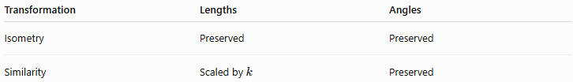
Transformation | Lengths | Angles
Isometry | Preserved | Preserved
Similarity | Scaled by $k$ | Preserved

10. Homothety Conditions
# Source: AI Source: Provided by: [Data Path: Persons Table -> ID Column: 1, Name_En Column: Motasem Essam] -> From: [ChatGPT] on [7/25/2026]
Definition
A Homothety Condition requires a figure to be transformed by dilation about a center.
For center $O$:
$$\boxed{\vec{OP^{'}}=k\vec{OP}}$$
Homothety therefore produces a figure similar to the original.
Example
If:
$$O=\left(0 , 0\right)$$
and:
$$P=\left(2 , 3\right)$$
with:
$$k=3$$
then:
$$P^{'}=\left(6 , 9\right)$$
Homothety is especially important in:
- similar figures,
- proportional geometry,
- triangle geometry,
- perspective configurations,
- construction problems.

11. Transformation-Composition Conditions
# Source: AI Source: Provided by: [Data Path: Persons Table -> ID Column: 1, Name_En Column: Motasem Essam] -> From: [ChatGPT] on [7/25/2026]
Definition
A Transformation-Composition Condition requires several transformations to be performed successively.
If $T_{1}$is followed by $T_{2}$:
$$\boxed{T=T_{2}∘T_{1}}$$
Example
First rotate a figure:
$${90}^{∘}$$
and then translate it by:
$$\left(2 , 3\right)$$
The final transformation is:
$$\boxed{T=T_{\text{translation}}∘T_{\text{rotation}}}$$
Important
In general:
$$T_{2}∘T_{1}≠T_{1}∘T_{2}$$
Therefore, the order of transformations can matter.

12. Inverse-Transformation Conditions
# Source: AI Source: Provided by: [Data Path: Persons Table -> ID Column: 1, Name_En Column: Motasem Essam] -> From: [ChatGPT] on [7/25/2026]
Definition
An Inverse-Transformation Condition requires a transformation to be reversed.
If:
$$T\left(F\right)=F^{'}$$
then:
$$\boxed{T^{-1}\left(F^{'}\right)=F}$$
Examples
The inverse of:
- translation by $\vec{v}$→ translation by $-\vec{v}$
- rotation by $θ$→ rotation by $-θ$
- reflection → the same reflection
- dilation by $k$→ dilation by $1/k$, when $k≠0$
Example
If:
$$T:\left(x , y\right)→\left(x , +4y-2\right)$$
then:
$$\boxed{T^{-1}:\left(x , y\right)→\left(x , -4y+2\right)}$$

13. Coordinate-Transformation Conditions
# Source: AI Source: Provided by: [Data Path: Persons Table -> ID Column: 1, Name_En Column: Motasem Essam] -> From: [ChatGPT] on [7/25/2026]
Definition
A Coordinate-Transformation Condition specifies how coordinates must change under a transformation.
Common transformations
Translation
$$\left(x , y\right)→\left(x , +ay+b\right)$$
Reflection in $x$-axis
$$\left(x , y\right)→\left(x , -y\right)$$
Reflection in $y$-axis
$$\left(x , y\right)→\left(- , xy\right)$$
Reflection in origin
$$\left(x , y\right)→\left(- , x-y\right)$$
Reflection in $y=x$
$$\left(x , y\right)→\left(y , x\right)$$
Rotation ${90}^{∘}$counterclockwise
$$\left(x , y\right)→\left(- , yx\right)$$
Rotation ${180}^{∘}$
$$\left(x , y\right)→\left(- , x-y\right)$$

14. Vector-Transformation Conditions
# Source: AI Source: Provided by: [Data Path: Persons Table -> ID Column: 1, Name_En Column: Motasem Essam] -> From: [ChatGPT] on [7/25/2026]
Definition
A Vector-Transformation Condition specifies a transformation through vectors or vector operations.
For a translation:
$$\boxed{\vec{OP^{'}}=\vec{OP}+\vec{v}}$$
For a dilation about the origin:
$$\boxed{\vec{OP^{'}}=k\vec{OP}}$$
Example
If:
$$\vec{OP}=\left(\begin{matrix}2 \\ 3\end{matrix}\right)$$
and:
$$\vec{v}=\left(\begin{matrix}4 \\ -1\end{matrix}\right)$$
then:
$$\vec{OP^{'}}=\left(\begin{matrix}6 \\ 2\end{matrix}\right)$$

15. Point-Mapping Conditions
# Source: AI Source: Provided by: [Data Path: Persons Table -> ID Column: 1, Name_En Column: Motasem Essam] -> From: [ChatGPT] on [7/25/2026]
Definition
A Point-Mapping Condition specifies that a particular point must correspond to another point under a transformation.
$$\boxed{T\left(P\right)=P^{'}}$$
Example
If $P=\left(2 , 4\right)$must map to $P^{'}=\left(5 , 1\right)$by translation, then:
$$\vec{PP^{'}}=\left(5 , -21-4\right) \\ \boxed{\vec{v}=\left(3 , -3\right)}$$
Therefore, the required translation is:
$$\boxed{T\left(x , y\right)=\left(x , +3y-3\right)}$$

16. Segment-Mapping Conditions
# Source: AI Source: Provided by: [Data Path: Persons Table -> ID Column: 1, Name_En Column: Motasem Essam] -> From: [ChatGPT] on [7/25/2026]
Definition
A Segment-Mapping Condition requires one segment to be mapped onto another segment.
$$\boxed{T\left(\overset{‾}{AB}\right)=\overset{‾}{A^{'}B^{'}}}$$
Example
If a rotation maps:
$$A→A^{'}$$
and:
$$B→B^{'}$$
then:
$$\boxed{\overset{‾}{AB}→\overset{‾}{A^{'}B^{'}}}$$
For an isometry:
$$AB=A^{'}B^{'}$$

17. Angle-Mapping Conditions
# Source: AI Source: Provided by: [Data Path: Persons Table -> ID Column: 1, Name_En Column: Motasem Essam] -> From: [ChatGPT] on [7/25/2026]
Definition
An Angle-Mapping Condition requires an angle to correspond to another angle under a transformation.
$$\boxed{T\left(∠ABC\right)=∠A^{'}B^{'}C^{'}}$$
For an isometry:
$$\boxed{m∠ABC=m∠A^{'}B^{'}C^{'}}$$
For a similarity transformation, angles are also preserved.
Example
If:
$$m∠ABC={60}^{∘}$$
then after a rotation:
$$\boxed{m∠A^{'}B^{'}C^{'}={60}^{∘}}$$

18. Figure-Mapping Conditions
# Source: AI Source: Provided by: [Data Path: Persons Table -> ID Column: 1, Name_En Column: Motasem Essam] -> From: [ChatGPT] on [7/25/2026]
Definition
A Figure-Mapping Condition requires an entire geometric figure to be transformed into another figure.
$$\boxed{T\left(F\right)=F^{'}}$$
Example
If:
$$T\left(△ABC\right)=△A^{'}B^{'}C^{'}$$
then:
$$A→A^{'} \\ B→B^{'} \\ C→C^{'}$$
The condition applies to the complete figure, not merely one point.

19. Transformation-Invariance Conditions
# Source: AI Source: Provided by: [Data Path: Persons Table -> ID Column: 1, Name_En Column: Motasem Essam] -> From: [ChatGPT] on [7/25/2026]
Definition
A Transformation-Invariance Condition requires a property to remain unchanged under a transformation.
If property $P$is invariant under $T$:
$$\boxed{P\left(F\right)=P\left(T\left(F\right)\right)}$$
Examples
Under an isometry:
- length is invariant,
- angle measure is invariant,
- area is invariant.
Under a similarity transformation:
- angle measure is invariant,
- ratios of corresponding lengths are invariant.
Example
A triangle has area:
$$20$$
After a rotation, its area remains:
$$\boxed{20}$$

20. Transformation-Symmetry Conditions
# Source: AI Source: Provided by: [Data Path: Persons Table -> ID Column: 1, Name_En Column: Motasem Essam] -> From: [ChatGPT] on [7/25/2026]
Definition
A Transformation-Symmetry Condition requires a figure to map onto itself under a transformation.
$$\boxed{T\left(F\right)=F}$$
Examples
A square satisfies:
$$R_{{90}^{∘}}\left(F\right)=F$$
Therefore, it has rotational symmetry of order $4$.
A rectangle satisfies:
$$R_{{180}^{∘}}\left(F\right)=F$$
Therefore, it has rotational symmetry of order $2$.
A circle satisfies:
$$R_{θ}\left(F\right)=F$$
for every rotation angle $θ$.

21. Transformation-Based Locus Conditions
# Source: AI Source: Provided by: [Data Path: Persons Table -> ID Column: 1, Name_En Column: Motasem Essam] -> From: [ChatGPT] on [7/25/2026]
Definition
A Transformation-Based Locus Condition defines a locus using a transformation relationship.
Example: Perpendicular Bisector
The perpendicular bisector of $AB$is the set of points $P$satisfying:
$$PA=PB$$
This can be understood through reflection: reflection across the perpendicular bisector exchanges $A$and $B$.
Another Example
If a point $P^{'}$must be the reflection of $P$across line $l$, then:
$$P^{'}=R_{l}\left(P\right)$$
This transformation condition determines the position of $P^{'}$.

23. Multiple-Transformation Conditions
# Source: AI Source: Provided by: [Data Path: Persons Table -> ID Column: 1, Name_En Column: Motasem Essam] -> From: [ChatGPT] on [7/25/2026]
Definition
A Multiple-Transformation Condition requires several transformation relationships simultaneously.
For example:
$$T_{1}\left(F\right)=F_{1}$$
and:
$$T_{2}\left(F_{1}\right)=F_{2}$$
and:
$$T_{3}\left(F_{2}\right)=F_{3}$$
Therefore:
$$\boxed{F_{3}=\left(T_{3}∘T_{2}∘T_{1}\right)\left(F\right)}$$
Example
A figure may be required to:
- rotate ${90}^{∘}$,
- reflect across the $x$-axis,
- translate by $\left(4 , 2\right)$.
The final figure must satisfy all three transformation conditions.

24. Combined Transformation Conditions
# Source: AI Source: Provided by: [Data Path: Persons Table -> ID Column: 1, Name_En Column: Motasem Essam] -> From: [ChatGPT] on [7/25/2026]
Definition
A Combined Transformation Condition combines transformation requirements with other geometric conditions.
For example:
$$T\left(F\right)=F^{'}$$
together with:
$$AB=10$$
and:
$$A^{'}B^{'}=10$$
Example
Find a point $P$that:
- lies on segment $AB$,
- is the reflection of $Q$across line $l$,
- satisfies $PA=5$.
The complete condition is:
$$\boxed{P∈\overset{‾}{AB} ∧ P=R_{l}\left(Q\right) ∧ PA=5}$$
The solution is obtained by combining incidence, transformation, and distance conditions.

Transformation Conditions and Preserved Properties
# Source: AI Source: Provided by: [Data Path: Persons Table -> ID Column: 1, Name_En Column: Motasem Essam] -> From: [ChatGPT] on [7/25/2026]
Different transformations preserve different geometric properties.
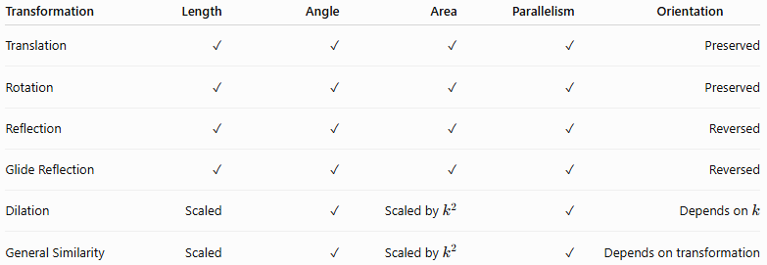
Transformation | Length | Angle | Area | Parallelism | Orientation
Translation | ✓ | ✓ | ✓ | ✓ | Preserved
Rotation | ✓ | ✓ | ✓ | ✓ | Preserved
Reflection | ✓ | ✓ | ✓ | ✓ | Reversed
Glide Reflection | ✓ | ✓ | ✓ | ✓ | Reversed
Dilation | Scaled | ✓ | Scaled by $k^{2}$ | ✓ | Depends on $k$
General Similarity | Scaled | ✓ | Scaled by $k^{2}$ | ✓ | Depends on transformation

Transformation Conditions and Congruence
# Source: AI Source: Provided by: [Data Path: Persons Table -> ID Column: 1, Name_En Column: Motasem Essam] -> From: [ChatGPT] on [7/25/2026]
If a figure can be transformed into another using only isometries:
$$\boxed{F^{'}≅F}$$
For example:
$$F^{'}=T_{\vec{v}}\left(R_{l}\left(F\right)\right)$$
where both transformations are isometries.
Therefore, the figures have:
- equal corresponding lengths,
- equal corresponding angles,
- equal area,
- equal shape and size.

Transformation Conditions and Similarity
# Source: AI Source: Provided by: [Data Path: Persons Table -> ID Column: 1, Name_En Column: Motasem Essam] -> From: [ChatGPT] on [7/25/2026]
If a figure is obtained using a similarity transformation:
$$\boxed{F^{'}∼F}$$
then corresponding lengths satisfy:
$$\frac{L^{'}}{L}=k$$
and:
$$\frac{A^{'}}{A}=k^{2}$$
For three-dimensional figures:
$$\boxed{\frac{V^{'}}{V}=k^{3}}$$
Thus:
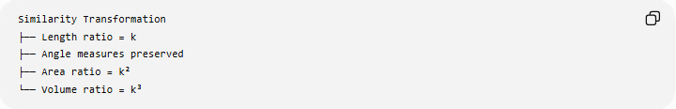
Similarity Transformation
├── Length ratio = k
├── Angle measures preserved
├── Area ratio = k²
└── Volume ratio = k³

Transformation Conditions and Symmetry
# Source: AI Source: Provided by: [Data Path: Persons Table -> ID Column: 1, Name_En Column: Motasem Essam] -> From: [ChatGPT] on [7/25/2026]
Symmetry is a special type of transformation condition.
General transformation:
$$\boxed{T\left(F\right)=F^{'}}$$
Symmetry:
$$\boxed{T\left(F\right)=F}$$
Therefore:
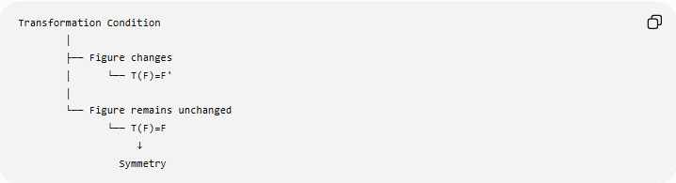
Transformation Condition
│
├── Figure changes
│ └── T(F)=F'
│
└── Figure remains unchanged
└── T(F)=F
↓
Symmetry

Transformation Conditions and Loci
# Source: AI Source: Provided by: [Data Path: Persons Table -> ID Column: 1, Name_En Column: Motasem Essam] -> From: [ChatGPT] on [7/25/2026]
Transformation conditions can also define loci.
For example, the set of points fixed by a reflection:
$$R_{l}\left(P\right)=P$$
is exactly the reflection axis $l$.
Thus:
$$\boxed{\text{Fixed points of a reflection}=\text{reflection axis}}$$
Similarly, the center of a ${180}^{∘}$rotation is the unique fixed point of that rotation.

Transformation Conditions in Coordinate Geometry
# Source: AI Source: Provided by: [Data Path: Persons Table -> ID Column: 1, Name_En Column: Motasem Essam] -> From: [ChatGPT] on [7/25/2026]
A transformation condition can be represented algebraically.
Translation
$$\left(x , y\right)→\left(x , +ay+b\right)$$
Reflection in $x$-axis
$$\left(x , y\right)→\left(x , -y\right)$$
Reflection in $y$-axis
$$\left(x , y\right)→\left(- , xy\right)$$
Rotation ${90}^{∘}$
$$\left(x , y\right)→\left(- , yx\right)$$
Rotation ${180}^{∘}$
$$\left(x , y\right)→\left(- , x-y\right)$$
Dilation about the origin
$$\left(x , y\right)→\left(k , xky\right)$$
These equations allow transformation conditions to be solved algebraically.

Transformation Conditions as Logical Conditions
# Source: AI Source: Provided by: [Data Path: Persons Table -> ID Column: 1, Name_En Column: Motasem Essam] -> From: [ChatGPT] on [7/25/2026]
Transformation conditions can be combined using logical operators.
AND Condition
Both transformations must hold:
$$C_{1}∧C_{2}$$
For example:
$$P∈l$$
and:
$$P=R_{m}\left(Q\right)$$
Therefore:
$$\boxed{P∈l∩R_{m}\left(Q\right)}$$
OR Condition
At least one transformation relationship holds:
$$C_{1}∨C_{2}$$
Sequential Condition
Transformations occur in a specified order:
$$\boxed{T_{2}∘T_{1}}$$

Transformation Conditions vs Other Geometric Conditions
# Source: AI Source: Provided by: [Data Path: Persons Table -> ID Column: 1, Name_En Column: Motasem Essam] -> From: [ChatGPT] on [7/25/2026]
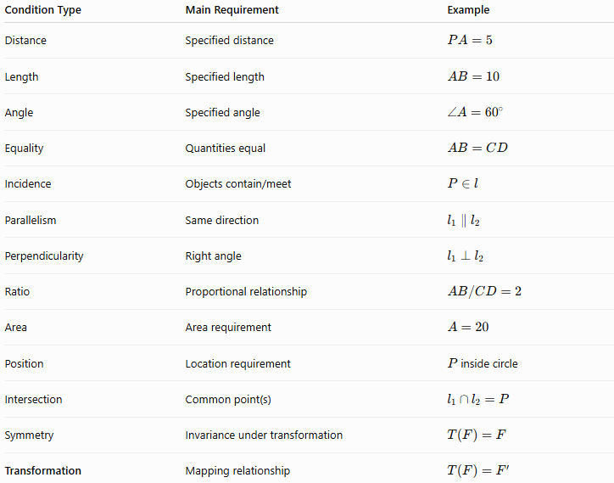
Condition Type | Main Requirement | Example
Distance | Specified distance | $$PA=5$$
Length | Specified length | $$AB=10$$
Angle | Specified angle | $$∠A={60}^{∘}$$
Equality | Quantities equal | $$AB=CD$$
Incidence | Objects contain/meet | $$P∈l$$
Parallelism | Same direction | $$l_{1}∥l_{2}$$
Perpendicularity | Right angle | $$l_{1}⊥l_{2}$$
Ratio | Proportional relationship | $$AB/CD=2$$
Area | Area requirement | $$A=20$$
Position | Location requirement | $P$inside circle
Intersection | Common point(s) | $$l_{1}∩l_{2}=P$$
Symmetry | Invariance under transformation | $$T\left(F\right)=F$$
Transformation | Mapping relationship | $$T\left(F\right)=F^{'}$$

Transformation Conditions — Mathematical Structure
# Source: AI Source: Provided by: [Data Path: Persons Table -> ID Column: 1, Name_En Column: Motasem Essam] -> From: [ChatGPT] on [7/25/2026]
The central structure is:
$$\boxed{\text{Original ObjectTransformed Object}}$$
More specifically:
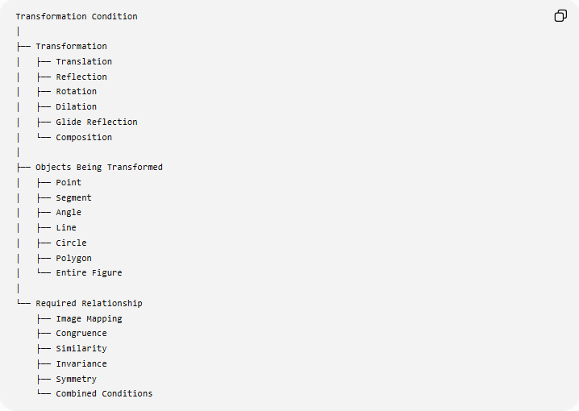
Transformation Condition
│
├── Transformation
│ ├── Translation
│ ├── Reflection
│ ├── Rotation
│ ├── Dilation
│ ├── Glide Reflection
│ └── Composition
│
├── Objects Being Transformed
│ ├── Point
│ ├── Segment
│ ├── Angle
│ ├── Line
│ ├── Circle
│ ├── Polygon
│ └── Entire Figure
│
└── Required Relationship
├── Image Mapping
├── Congruence
├── Similarity
├── Invariance
├── Symmetry
└── Combined Conditions

Key Formulas
# Source: AI Source: Provided by: [Data Path: Persons Table -> ID Column: 1, Name_En Column: Motasem Essam] -> From: [ChatGPT] on [7/25/2026]
General Transformation
$$\boxed{T\left(F\right)=F^{'}}$$
Fixed Figure / Symmetry
$$\boxed{T\left(F\right)=F}$$
Translation
$$\boxed{\left(x , y\right)→\left(x , +ay+b\right)}$$
Reflection in $x$-axis
$$\boxed{\left(x , y\right)→\left(x , -y\right)}$$
Reflection in $y$-axis
$$\boxed{\left(x , y\right)→\left(- , xy\right)}$$
Rotation ${90}^{∘}$Counterclockwise
$$\boxed{\left(x , y\right)→\left(- , yx\right)}$$
Rotation ${180}^{∘}$
$$\boxed{\left(x , y\right)→\left(- , x-y\right)}$$
Dilation
$$\boxed{\vec{OP^{'}}=k\vec{OP}}$$
Similarity
$$\boxed{\frac{A^{'}B^{'}}{AB}=k}$$
Area Scaling
$$\boxed{\frac{A^{'}}{A}=k^{2}}$$
Volume Scaling
$$\boxed{\frac{V^{'}}{V}=k^{3}}$$
Isometry
$$\boxed{P^{'}Q^{'}=PQ}$$
Composition
$$\boxed{T=T_{n}∘⋯∘T_{2}∘T_{1}}$$
Inverse
$$\boxed{T^{-1}\left(T\left(F\right)\right)=F}$$

Classification Summary
# Source: AI Source: Provided by: [Data Path: Persons Table -> ID Column: 1, Name_En Column: Motasem Essam] -> From: [ChatGPT] on [7/25/2026]
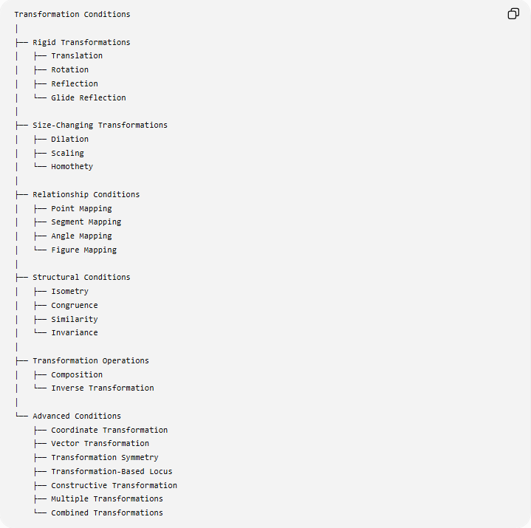
Transformation Conditions
│
├── Rigid Transformations
│ ├── Translation
│ ├── Rotation
│ ├── Reflection
│ └── Glide Reflection
│
├── Size-Changing Transformations
│ ├── Dilation
│ ├── Scaling
│ └── Homothety
│
├── Relationship Conditions
│ ├── Point Mapping
│ ├── Segment Mapping
│ ├── Angle Mapping
│ └── Figure Mapping
│
├── Structural Conditions
│ ├── Isometry
│ ├── Congruence
│ ├── Similarity
│ └── Invariance
│
├── Transformation Operations
│ ├── Composition
│ └── Inverse Transformation
│
└── Advanced Conditions
├── Coordinate Transformation
├── Vector Transformation
├── Transformation Symmetry
├── Transformation-Based Locus
├── Constructive Transformation
├── Multiple Transformations
└── Combined Transformations

Key Points
# Source: AI Source: Provided by: [Data Path: Persons Table -> ID Column: 1, Name_En Column: Motasem Essam] -> From: [ChatGPT] on [7/25/2026]
- A Transformation Condition specifies a required mapping between geometric objects.
- Its fundamental form is:
$$\boxed{T\left(F\right)=F^{'}}$$
- Translation, rotation, reflection, and glide reflection are isometries.
- Dilation and general similarity transformations change size while preserving shape.
- A symmetry condition is a special transformation condition:
$$\boxed{T\left(F\right)=F}$$
- Transformation conditions can apply to points, segments, angles, lines, circles, polygons, and complete figures.
- Transformations can be represented geometrically, algebraically, with coordinates, or with vectors.
- Transformations can be combined:
$$T_{2}∘T_{1}$$
- Every invertible transformation has an inverse:
$$T^{-1}$$
- Transformation conditions can be combined with distance, length, angle, incidence, ratio, parallelism, perpendicularity, intersection, and symmetry conditions.

Conclusion
# Source: AI Source: Provided by: [Data Path: Persons Table -> ID Column: 1, Name_En Column: Motasem Essam] -> From: [ChatGPT] on [7/25/2026]
Transformation Conditions describe geometric requirements in terms of how objects or figures must move, correspond, change size, or remain invariant under transformations. They provide a unified way to express translations, reflections, rotations, dilations, similarities, congruences, compositions, inverse transformations, and symmetry.
Their central idea is:
$$\boxed{\text{Transformation Condition }=\text{ Required Geometric Mapping}}$$
with the fundamental relationship:
$$\boxed{T\left(F\right)=F^{'}}$$
and, when the transformation represents symmetry:
$$\boxed{T\left(F\right)=F}$$
Thus, Transformation Conditions form an important bridge between geometric constructions, coordinate geometry, congruence, similarity, symmetry, loci, and geometric proofs.

